

DIU ICE ETE Alumni Association
Department of Information and Communication Engineering
Daffodil International University
Attendance Sheet

Venue : Conference Room, ICE, DIU
Date : 10/01/2026

SL | Name | Designation | Signature
01 | Ferdosh Alam | President | 
02 | Pranoy Majumder | Vice President | 
03 | Md Abdullah Al Maruf | General Secretary | 
04 | Golam Sarour Prince | Joint Secretary | 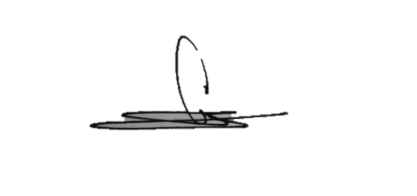
05 | M Abdullah Al Mamun | Treasurer | 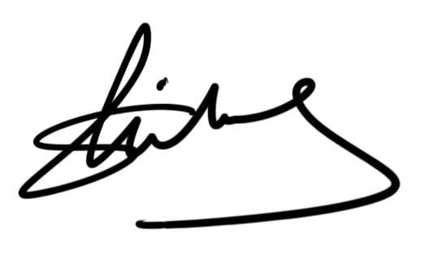
06 | Sadia Shahnewaz | PR Secretary | 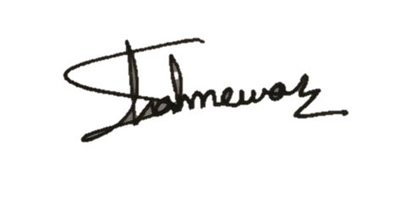
07 | Onamika Islam | Office Secretary
08 | Shafiur Rahman | Education, Sports & Cultural Secretary | 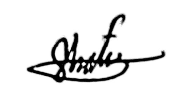
09 | Saed Sultan Zisan | Executive Member
10 | Humayra Parvin Tisha | Executive Member

DIU ICE ETE Alumni Association
Department of Information and Communication Engineering
Daffodil International University
Attendance Sheet

Venue : Online
Date : 28/02/2026

SL | Name | Designation | Signature
01 | Ferdosh Alam | President
02 | Pranoy Majumder | Vice President
03 | Md Abdullah Al Maruf | General Secretary
04 | Golam Sarour Prince | Joint Secretary
05 | M Abdullah Al Mamun | Treasurer
06 | Sadia Shahnewaz | PR Secretary
07 | Onamika Islam | Office Secretary
08 | Shafiur Rahman | Education, Sports & Cultural Secretary
09 | Saed Sultan Zisan | Executive Member
10 | Humayra Parvin Tisha | Executive Member

DIU ETE ICE Alumni Association
Department of Information and Communication Engineering
Daffodil International University
Attendance Sheet

Venue : Office of the Head, ICE
Date : 02/05/2026

SL | Name | Designation | Signature
01 | Ferdosh Alam | President
02 | Pranoy Majumder | Vice President
03 | Md Abdullah Al Maruf | General Secretary
04 | Golam Sarour Prince | Joint Secretary
05 | M Abdullah Al Mamun | Treasurer
06 | Sadia Shahnewaz | PR Secretary
07 | Onamika Islam | Office Secretary
08 | Shafiur Rahman | Education, Sports & Cultural Secretary
09 | Saed Sultan Zisan | Executive Member
10 | Humayra Parvin Tisha | Executive Member

